# Results:

## ANSYS CFX 16.1

### Iteration Error Study

This study was performed with mesh 1 and the series of convergence targets ranging from 10-3 to 10-6 . k-ω SST was the turbulence model used for the simulations. The simulations used pure air at fuel jet & co-flow inlet. Comparison of the velocity component profiles for different convergence targets along with the experimental data is shown in figure 12.1(a)-(d).The experimental flow field data has been provided in the form of three data sets, but the comparison of the velocity profiles with the experimental data will only be shown for the data set 2.

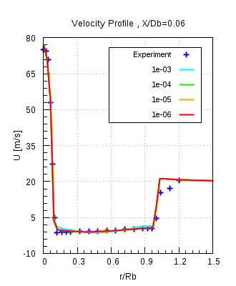 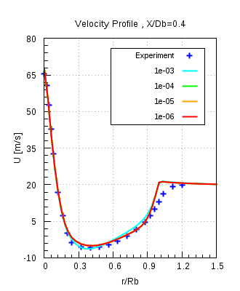 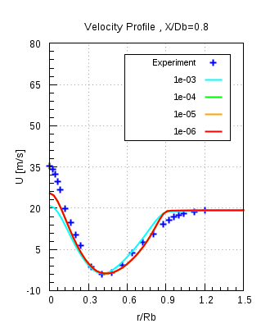

Figure 12.1(a)

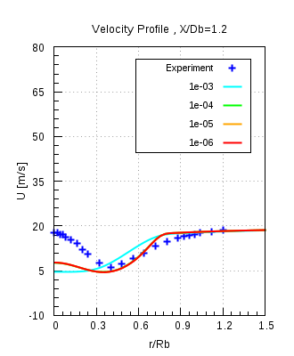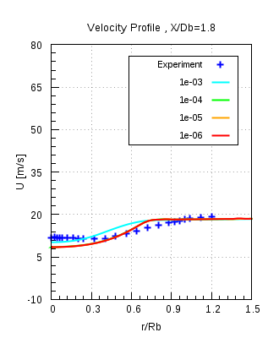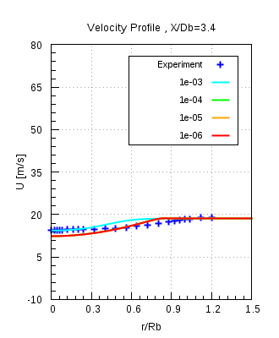

Figure 12.1(b)

Figure 12.1(a) & (b) shows the axial velocity component profile, plotted againt the normalised radial locations, compared with the experimental data. It is seen from the figures above, that velocity profiles for all, except for convergence target of 10-3, overlap over each other and makes it difficult to decide which is the sufficient convergence level. Hence the magnitude of velocity, for different convergence levels, was compared in ANSYS CFD Post.Depending on the smallest velocity difference, between the convergence targets, it was decided to have 10-4 as the appropriate convergence level.

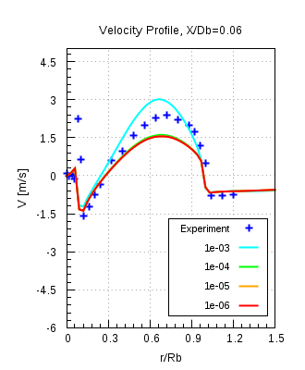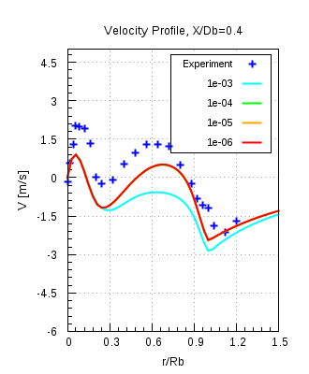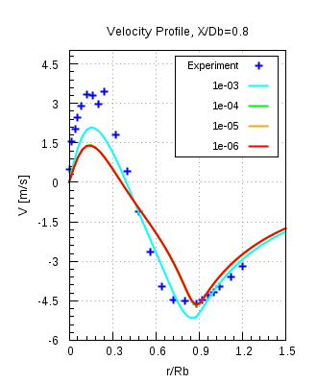

Figure 12.1(c)

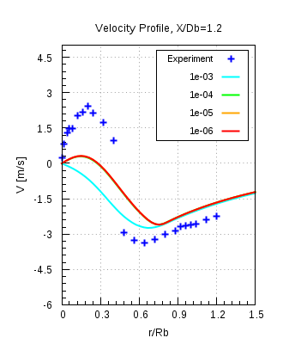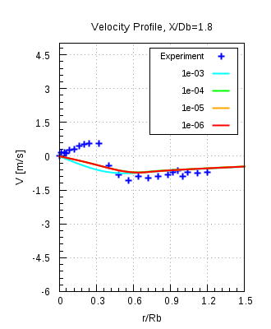 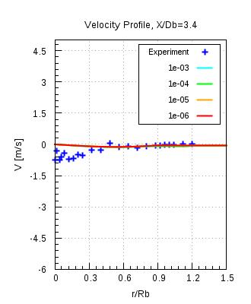

Figure 12.1(d)

Figure 12.1(c) & (d) shows the radial velocity component profiles, plotted against the normalised radial locations, compared with the experimental data. The same behaviour is seen here with the radial velocity component profiles, as pointed out above.

### Spatial Discretization Error (Flow field):

This investigation was carried out with the mesh 1, 2, 3 and k-ω SST model. Pure air was used at both fuel jet and co-flow inlets. The purpose of this study was to obtain the mesh independent results. Conservation and convergence targets were 5.10-4 and 10-4 respectively. Results obtained from the simulations, velocity profiles, were compared with the experimental data. Results will only be shown for the data set 2.

Figures 12.2(a) & (b) shows the comparison of the axial velocity component profiles with the experimental data. Here also the comparison doesnot allows us to select an appropriate mesh resolution. It was decided to choose mesh 2 as the final resolution considering mesh 1 to be too coarse and mesh 3 to be too fine. All meshes deliver mesh independent results. This spatial discretization study has been performed for the Flow field and before choosing the final mesh resolution a spatial discretization study has to be performed for Mixing field.

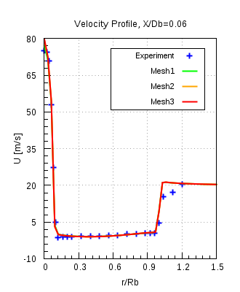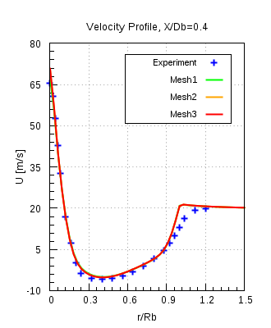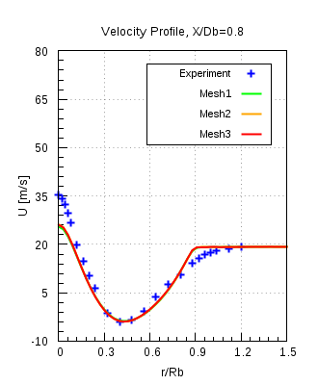

Figure 12.2(a)

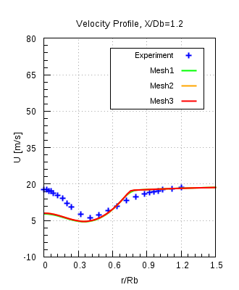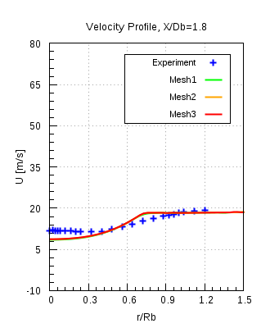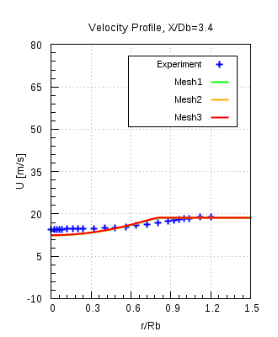

Figure 12.2(b)

### Spatial Discretization study (Mixing field):

In this study a combination of different fuels with same velocity 50 m/s have been used at the fuel jet inlet with air flowing at 20 m/s through the co-flow. Mesh 1, 2, 3 and k-ω SST turbulence model are used for the calculations. The same convergence criteria as mentioned in the previous study has been used here. The comparison of the numerical results will be done with the experimental data for mixing fraction profiles. Table shows the different fuels that were used at fuel jet inlet.

CNG :

In order to obtain correct and trustworthy results a great care was applied to confirm that all the prescribed convegence criteria viz. convergence and conservation target were achieved. Figure 12.3(a) shows the residual values plotted against the number of iterations. Maximum was chosen as the type of residuals. It is seen from the plot that for every quantity the residuals drop even less than the level of 10-5, which is less than what has been a specified criterion of 10-4.

Figure12.3(b) shows the (%) imbalance in the conserved quantities plotted against the number of iterations. Mass fraction imbalance for fuel is 100 % at outlet, in the beginning, since there is no fuel at outlet. After 50 iterations the fuel reach the outlet and the imbalances start to reduce and then gradually it will approach to a specified smaller value of conservation target.

In this case the solver will stop only after it either reaches a maximum number of iterations or will achieve all the convergence criteria and stop.Here the residual convergence history and Imbalance monitors are only shown for mesh 2. For other meshes it can be found in Appendix.

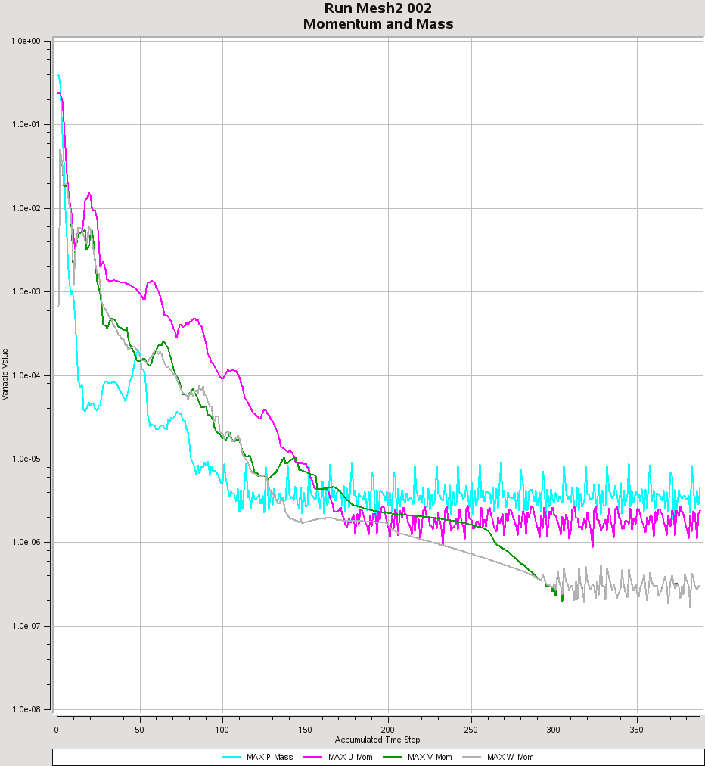

Figure 12.3(a)

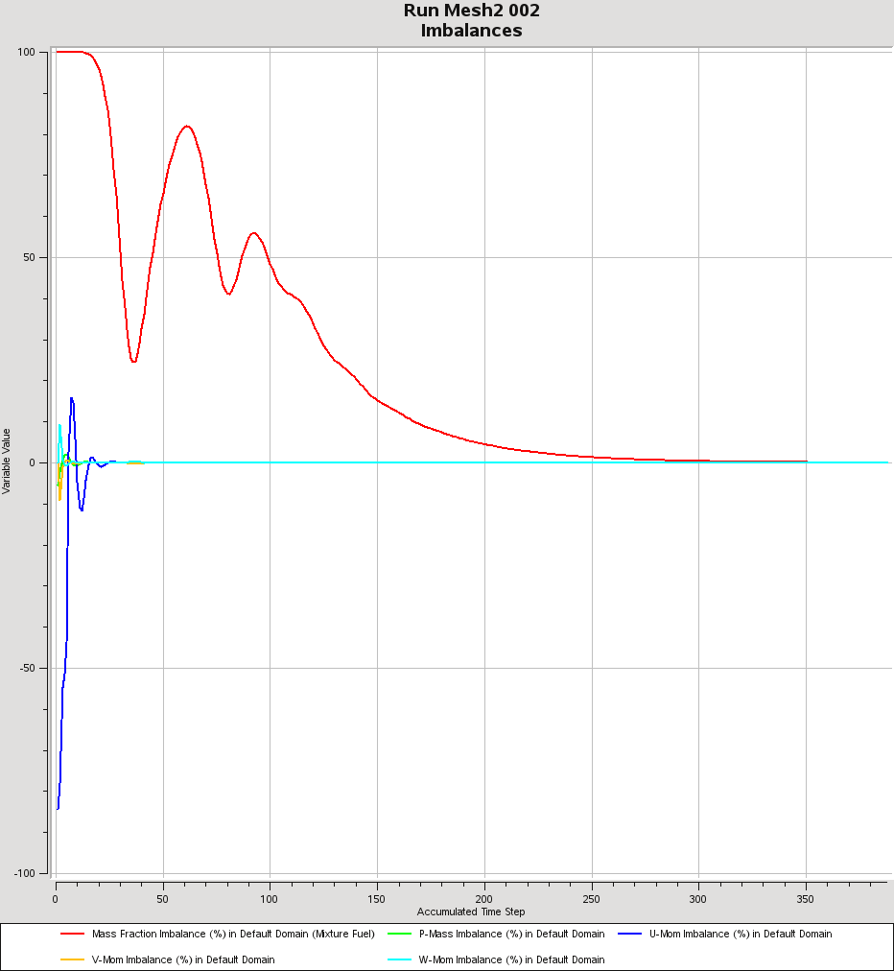

Figure 12.3(b)

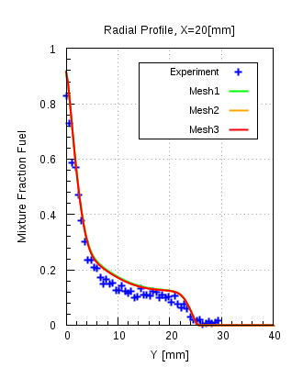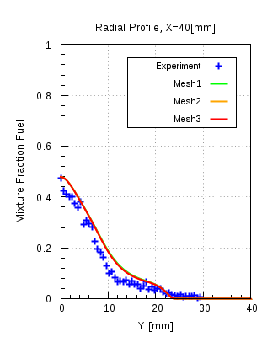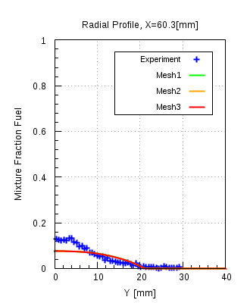

Figure 12.3(c)

Ethylene:

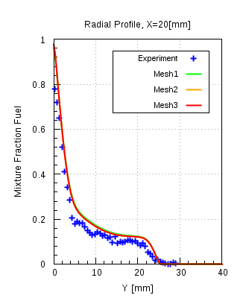 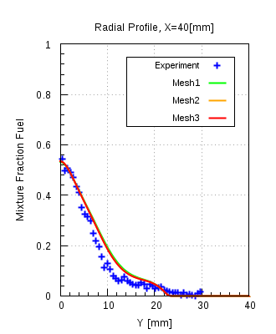 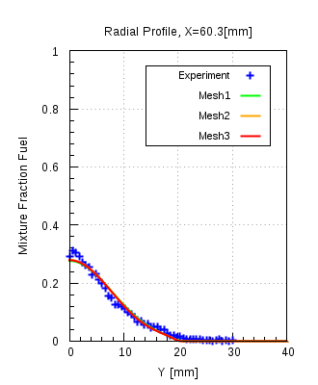

Figure 12.3(d)

LPG:

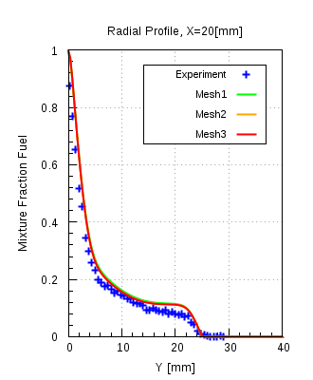 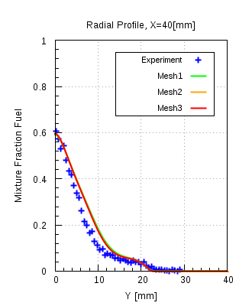 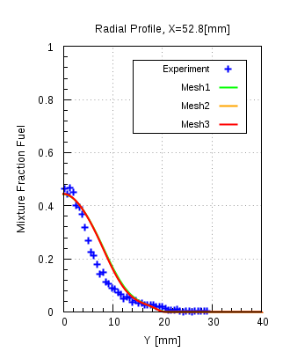

Figure 12.3(e)

Figure 12.3(c)-(e) shows the comparison of the mixture fraction profiles obtained from numerical results and are compared with the experimental data. The mixture fraction profiles of all meshes overlap over one another. All meshes achieved the specified convergence criteria.For the same reasons mentioned in the previous spatial discretzation study applies here also and mesh 2 was chosen to be the final mesh resoultion to carry out further investigation.

### Model Error Study:

The following table shows the array of the simulations that had been carried out, for all mesh resolutions, in this study.

|  |  |  |
| --- | --- | --- |
| Model | Fuels | Velocity |
| k-ω SST,  Standard k-ε | CNG | 50 |
| 85 |
| 143 |
| Ethylene | 50 |
| 63 |
| 80 |
| LPG | 50 |
| 70 |

Table 9

Model Error study was performed with k-ω SST and standard k-ε turbulence models.The comparison of the radial mixture fraction profiles obtained from the numerical results will be compared with the experimental data and will be shown only at the locations X = 20, 40 and 60.3 [mm]. Here the comparison will only be shown for the mesh 2, which is the selected mesh resolution,for fuels CNG and Ethylene with UJ = 50 m/s. Other comparisons can be found in Appendix. All simulations achieved the specified convergence criteria.

CNG:

UJ = 50 m/s

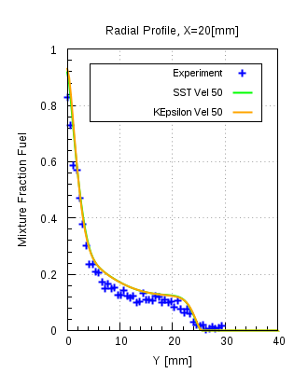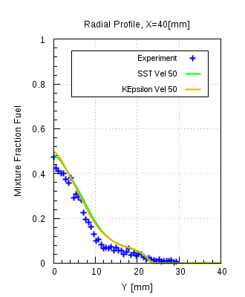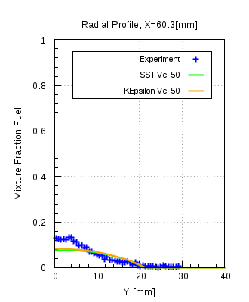

Figure 12.4(a)

Figure 12.4(a) shows the comparison of the radial mixture fraction profiles for the numerical results of CNG fuel at UJ = 50 m/s and experimental data.The numerical mixture fraction profiles for both models are in good agreement with each other as well as with the experimental data, but at certain intermediate locations in the domain a noticeable difference between the two models was observed. Figure 12.4(b) shows the locations, between which the differences in the model prevails. Figures 12.4(c)-(e) shows the plots where this difference was observed.

Figure 12.4(b)

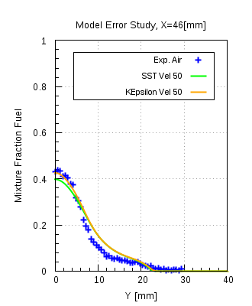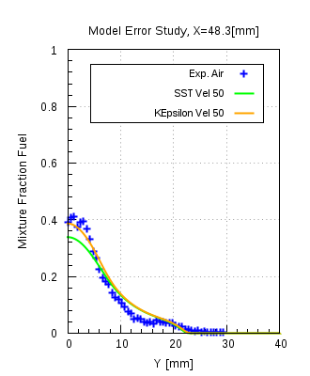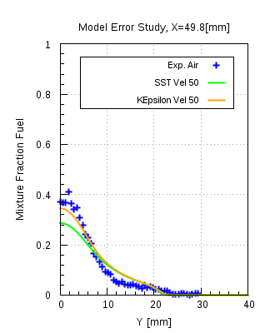

Figure 12.4(c)

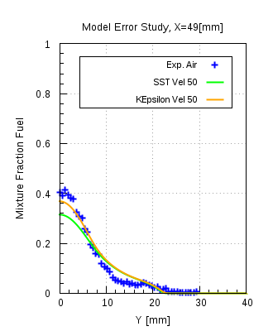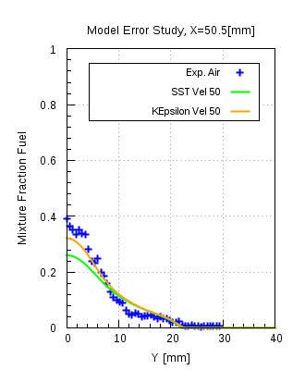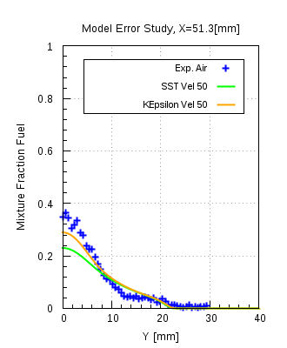

Figure 12.4(d)

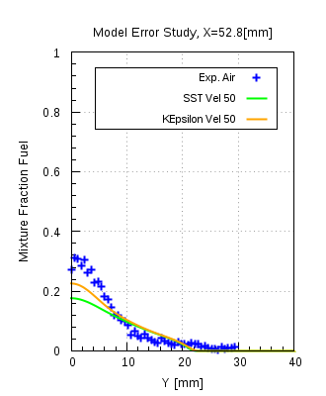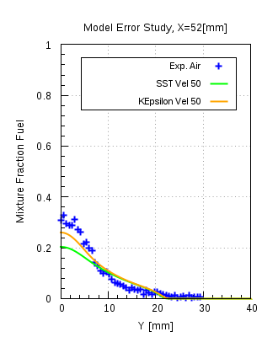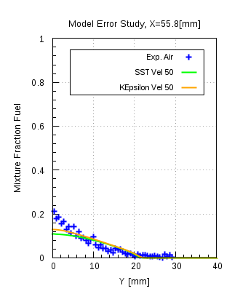

Figure 12.4(e)

It is seen from the figures that the difference is existing at certain locations, but then it continues to reduce further on to deliver almost identical profiles.

From the figure 12.4(f), a double-vortex structure is seen in the recirculation zone which controls the flow and mixing patterns: an inner vortex near to the fuel jet and an outer vortex which lies in between the inner vortex and the co-flow air. The outer vortex is larger and extends up to 70% of the bluff-body diameter radially and around one bluff-body diameter axially. The inner vortex is narrower and its centre core shifts downward with the change of the flow conditions at fuel jet inlet.

Figure 12.4(f)

Figure 12.4(f) also shows the comparison of the streamlines for k-ω SST, standard k-ε model along with the locations at which the differences were observed. The comparison of the streamlines for both the models showed that they predict different length of recirculation zone, defined as the axial location at which the co-flowing air reaches a stagnation point [8]. Yellow and red lines indicate the beginning and the end of the region in between which both the models showed noticeable differences in the mixture fraction profiles. It can be seen that for the same measurement location different values of mixture fraction are predicted and the reason is the k-ε model predicts a bit longer recirculation region as compared to the k-ω SST model. Fig. 12.4 (g) shows the comparison of the mass fraction contours for k-ω SST and standard k-ε model. It is seen from the plots that the mixing is slightly overpredicted by the k-ωSST model compared to the standard k-ε model. Overprediction is seen only in a small region in between yellow and red line.

Figure 12.4(g)

Ethylene:

Figure 12.4(h) shows that the radial mixture fraction profiles of k-ω SST and standard k-ε models compared with the experimental data. Ethylene is used as fuel at jet inlet with UJ = 50 m/s. Both models show good agreement to the experimental data and are consistent with each other as well. Figure 12.4(i) shows the comparison with the streamlines generated from the experimental data and the streamlines obtained from numerical results using two different turbulence models. It is seen from the plots that the mixture fraction profiles are in good agreement with each other as well as the experimental data.

UJ = 50 m/s

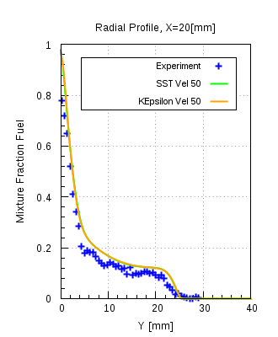 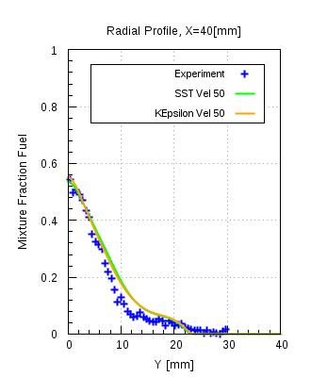 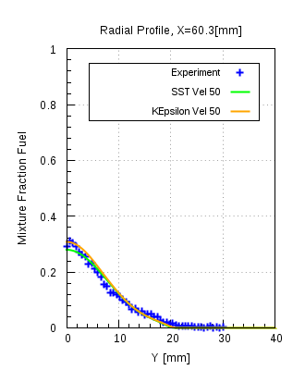

Figure 12.4(h)

Figure 12.4(i)

Comparison in figure 12.4(i) shows two fully developed vortices in the recirculation zone and mainly they are showing the same orientation as shown by the experimentally generated vortices, a little bit over-predicted in case of k-ε model. The length of the recirculation zone extends upto one DB [7] and the same is being observed from the numerical results.

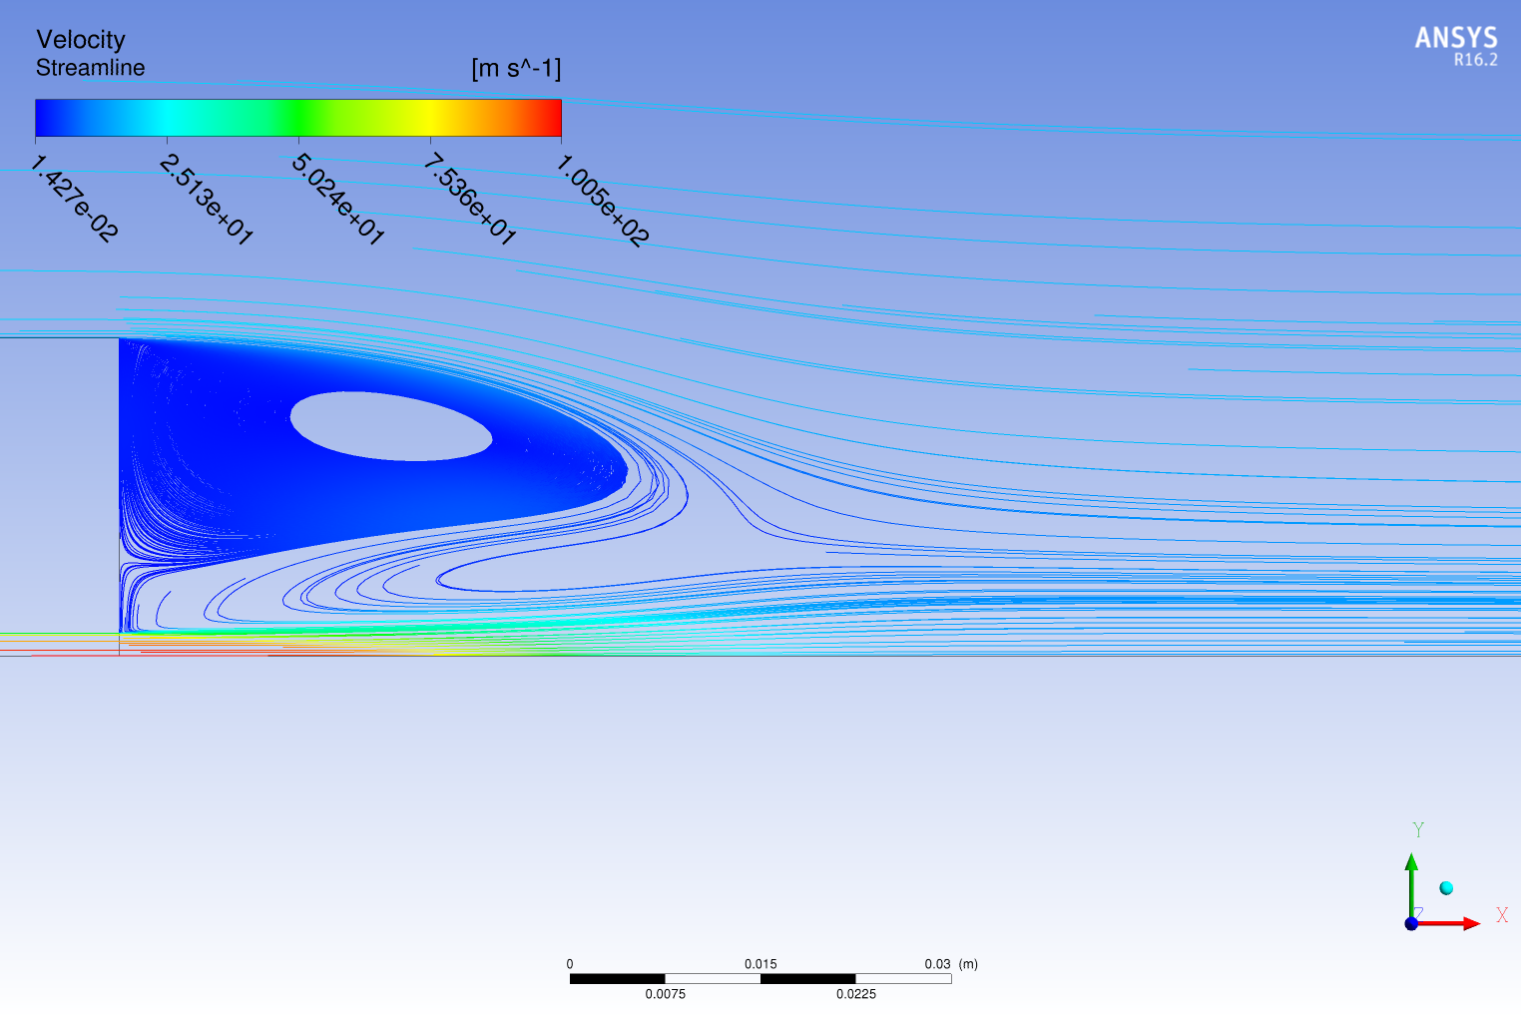

Ethylene, UJ = 80 [m/s]

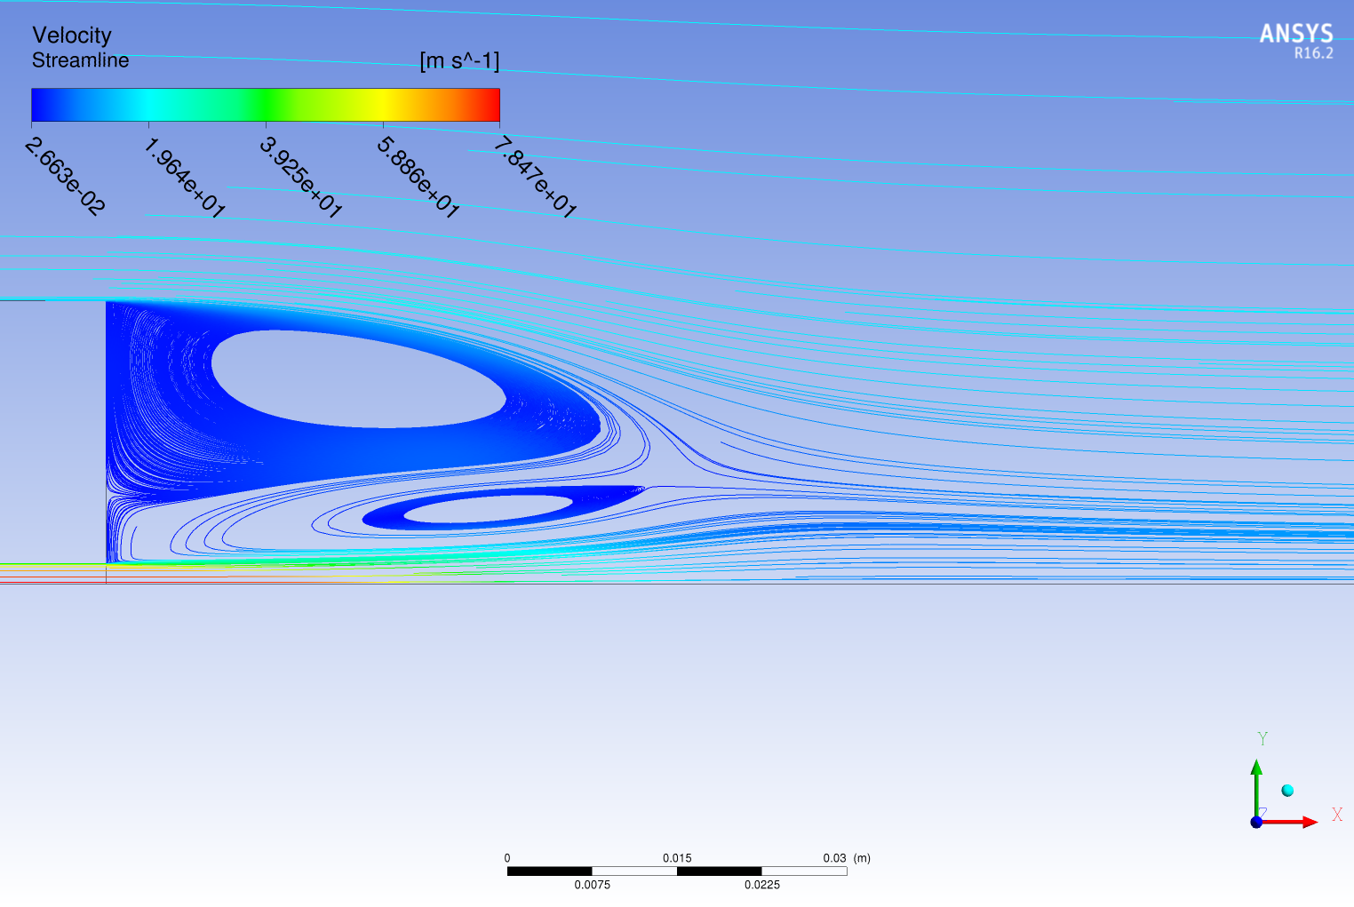

Ethylene, UJ = 63 [m/s]

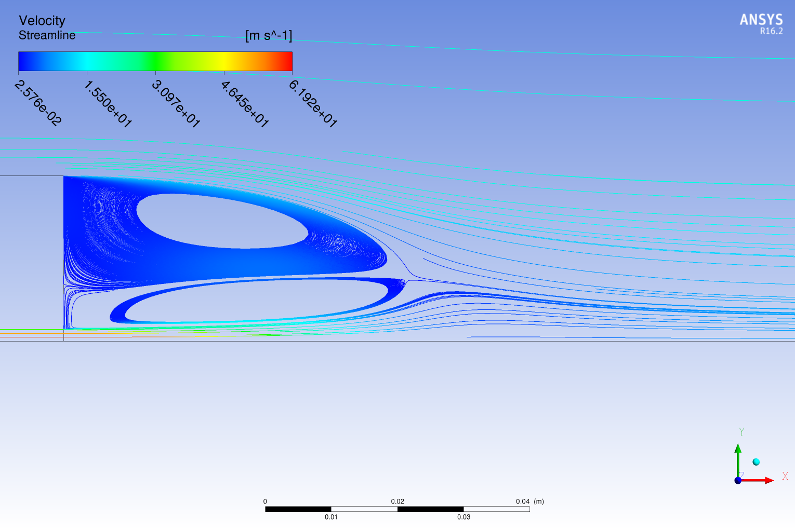

Ethylene, UJ = 50 [m/s]

Figure 12.4(j)

Figure 12.4(j) shows the comparison of streamlines generated with different fuel jet velocities viz. 50, 63 and 80, with fuel Ethylene. It is apparent that the flow field in the lower (50 m/s) and intermediate jet velocity (63 m/s) flows shows a double-vortex structure in the recirculation zone, while in the high-velocity (80 m/s) case the inner vortex has almost lost its circulation pattern. In the intermediate jet velocity case, the central core of the inner vortex shifts downstream the bluff body, and in the high jet velocity case this shift continues until the inner vortex disappears and part of the gases circulated back by the outer vortex is convected downstream. The same phenomenon occurs for other fuel mixtures and the transition from double- to single-vortex structure occurs at different jet velocities.

## ANSYS Fluent 17.0:

The same studies as in ANSYS CFX 16.1 were carried out with ANSYS Fluent 17.0. From the iteration and spatial discretization error study, RMS Residual < 10-7 was chosen as the convergence criteria and mesh resoultion of mesh 2 respectively. Here only the results of model error study will be discussed.

### Model Error Study

This study was carried out with k-ω SST model, standard k-ε and realizable k-ε model, the results were compared with each other as well as with the experimental data. The results shown here would be only for the mesh 2. Table shows the array of simulations carried out for this study.

|  |  |  |
| --- | --- | --- |
| Model | Fuels | Velocity |
| k-ω SST,  standard k-ε,  realizable k-ε model | CNG | 50 |
| 85 |
| 143 |
| Ethylene | 50 |
| 63 |
| 80 |
| LPG | 50 |
| 70 |

Table 10

CNG:

UJ = 50 m/s

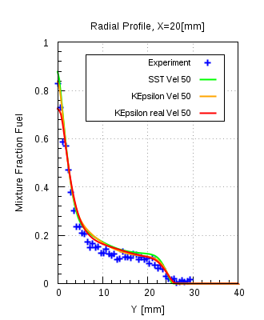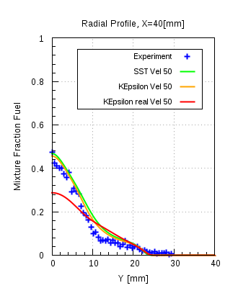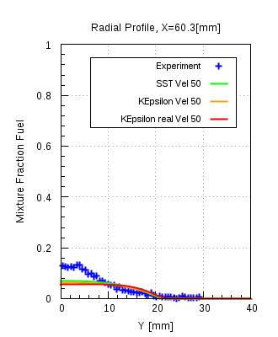

Figure 12.5(a)

Figure 12.5(a) shows that the comparison of the radial mixture fraction for the numerical data for CNG at UJ = 50 m/s, compared with the experimental data. Mixture fraction profiles for k-ω SST and standard k-ε are in good agreement with the experimental data and consistent with each other, but realizable k-ε model over-predicts the mixing significantly downstream X > 40 [mm]. It predicts that jet has sufficiently mixed with the surrounding air by downstream location X = 46 [mm]. Figure 12.5(b) shows the locations where the mixing is over-predicting by the realizable k-ε model. The difference start to reduce between the profiles, when the other models start to predict that the jet has sufficient mixed or the diffusion of jet has occurred.

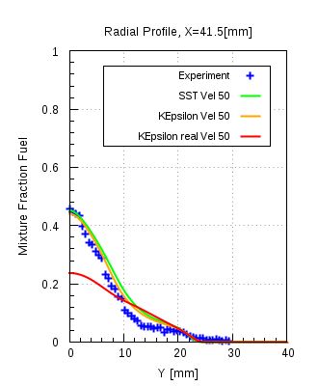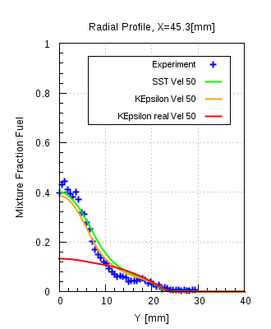

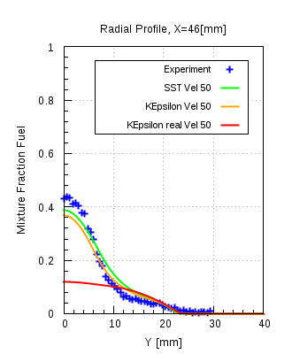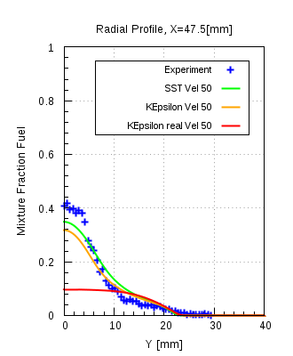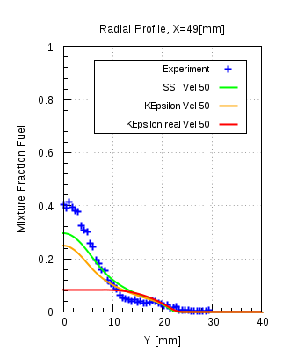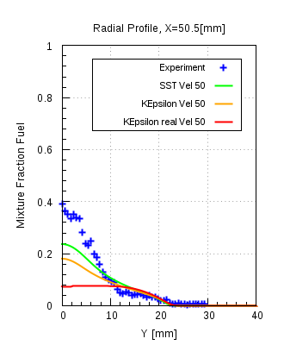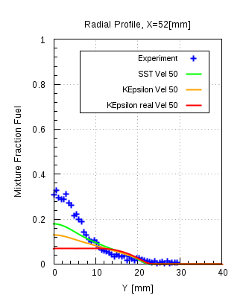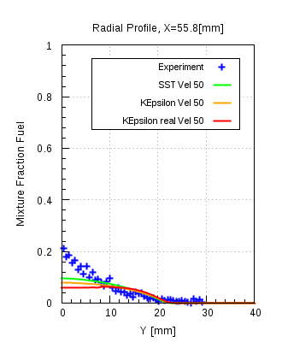

Figure 12.5(b)

Figure 12.5(c)

Figure 12.5(c) shows the comparison of the stream lines for all three models. Yellow and red lines indicate the region in between which the differences in the mixture fraction profiles are observed.

All three models predict different length of recirculation zones. As seen the realizable k-ε model

Predicts the smallest length of recirculation zone compared to the other two models. Also the orientation of the smaller vortex near the jet is tending more upwards, rather than extending in the downstream direction.

Figure 12.5(d) shows the comparison of the mass fraction contour plots for all three models. It is seen from the comparison that standard k-ε model over-predicts the mixing slightly, but realizable k-ε model over-predicts the mixing significantly.

Figure 12.5(d)

Ethylene:

Figures 12.5(e)-(g) shows radial profiles of the mean mixture fraction at different axial locations for the low (50 m/s), intermediate (63 m/s) and highest (80 m/s) jet velocity flows. Simulations from the all the three turbulence models are also plotted for the same axial locations. The agreement between measurements and computations, with intermediate and highest jet velocities is similar to that observed for the low-velocity jets.

From figure 12.4(j), it is clear that the transition from double to single vortex in the recirculation zone occurs between these intermediate and highest jet velocities. However, from figures 12.5(e)-(g) it is also apparent that the changes in the structure of the flow pattern in the recirculation zone and the downward shift of the inner vortex have minor effects on the mixing field close to the bluff-body i.e. the jet with the highest velocity is sharper compared to the other two velocities. It is worth noting that the transition from the closed to the open vortex structure by itself does not have a major effect on the flow and mixing fields. The same can be observed for fuel LPG, from figures 12.5(h)-(i) where the comparison of the mean mixture fraction with the experimental data is done. Apart from that in all cases realizable k-ε model over-predicts the mixing in comparison to the other models and the experimental data as well.

UJ = 50 m/s

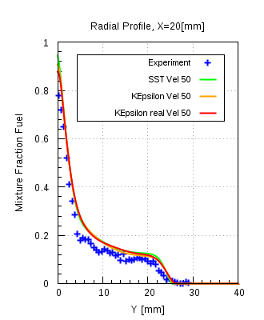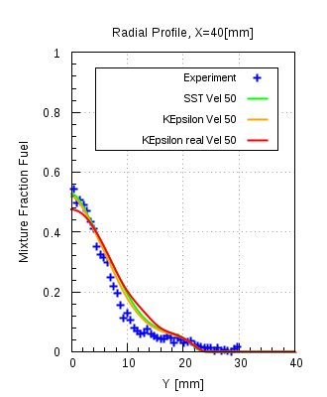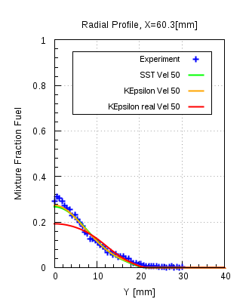

Figure 12.5(e)

UJ = 63 m/s

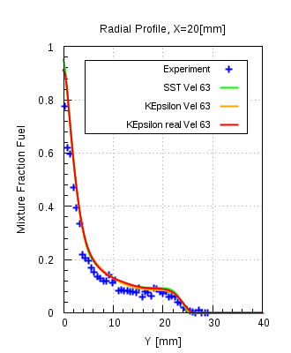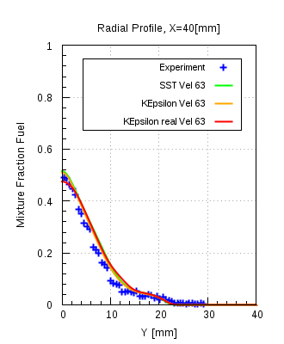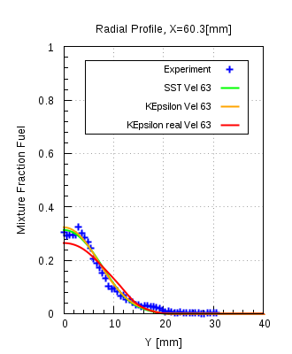

Figure 12.5(f)

UJ = 80 m/s

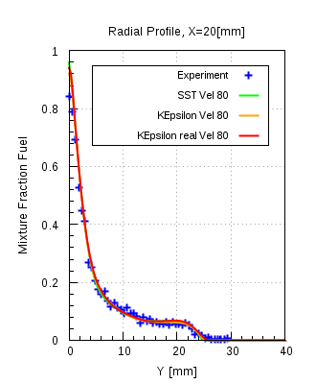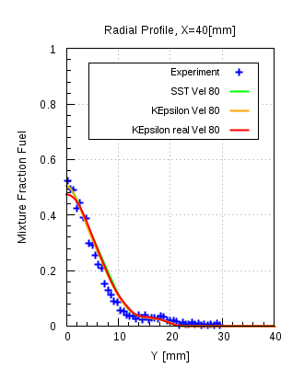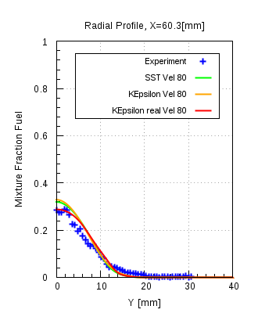

Figure 12.5(g)

LPG:

UJ = 50 m/s

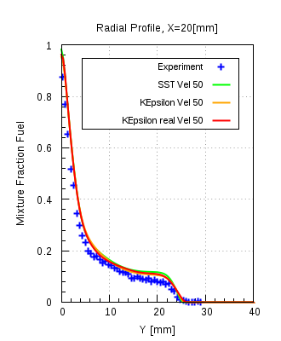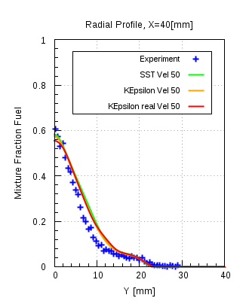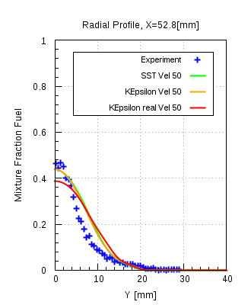

Figure 12.5(h)

UJ = 70 m/s

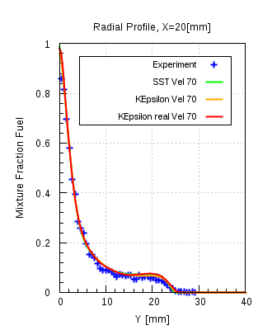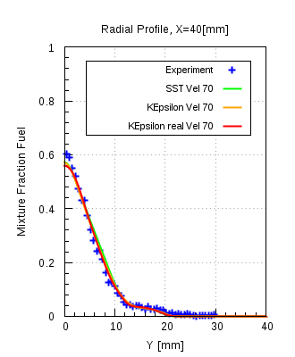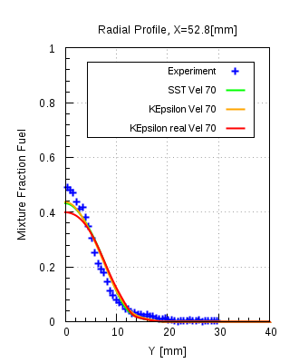

Figure 12.5(i)

## Solver comparison between ANSYS CFX 16.1 and ANSYS Fluent 17.0:

In this study a comparison of the results obtained from the turbulence models of the two solvers, with each other as well as with experimental data, is carried out. This comparison is only performed with the mixing field data. The comparison of the standard k-ε, realizable k-ε and k-ω SST models from ANSYS Fluent 17.0 will be done with standard k-ε and k-ω SST models of ANSYS CFX 16.1 respectively.Figure 12.6(a) shows the radial mixture fraction profiles of the numerical results compared with the experimental data. It is seen that the standard k-ε models of both the solvers are in good agreement with the experimental data. Also they both deliver almost consistent results to each other. Realizable k-ε model over-predicts the mixing significantly from the axial location X = 40 [mm] and continues to do so until the location X= 58.8 [mm]. Justification for the same was obtained from the comparison of the mixture fraction contours. Streamline comparison showed that realizable k-ε model under- predicts the length of recirculation zone (Shown in Appendix)

### CNG

#### k-ε model:

UJ  = 50 m/s

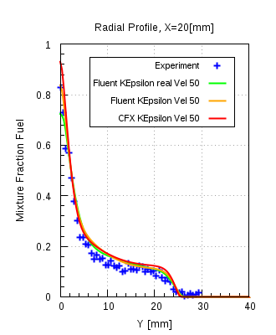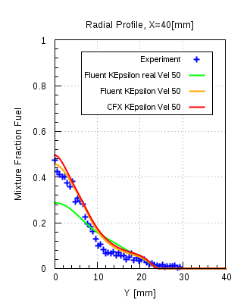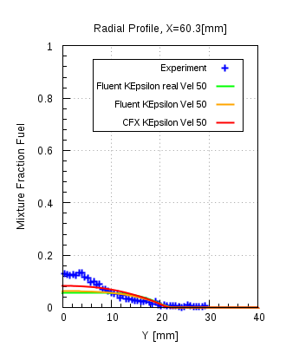

Figure 12.6(a)

UJ  = 85 m/s

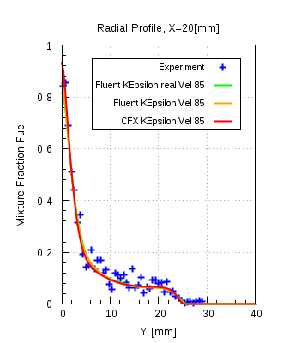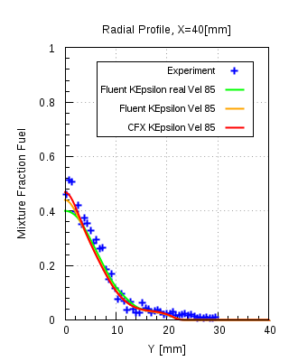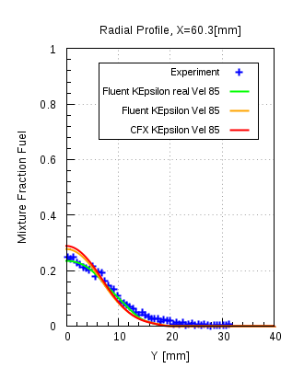

Figure 12.6(b)

UJ  = 143 m/s

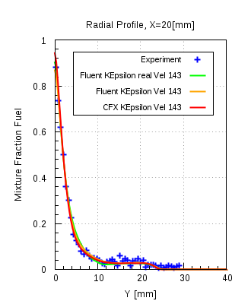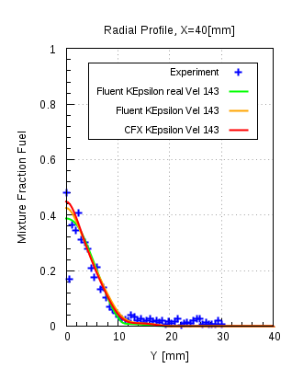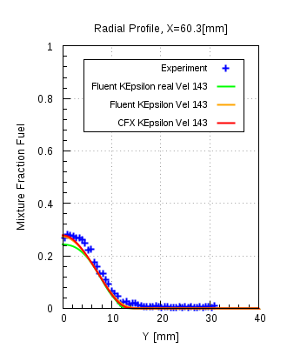

Figure 12.6(c)

From figure 12.6(b)&(c) it can be seen that with the same fuel, but with different momentum at the jet inlet, realizable k-ε model does not over-predicts the mixing as significantly as it does in the case of UJ = 50 m/s. Apart from that standard k-ε model for both solvers are consistent with each other and are in good agreement with the experimental data.

From the figure 12.6(d)-(f) it can be seen that the radial mixture fraction profiles for the k-ω SST models for both the solvers are consistent with each other and are in good agreement with each other.

#### k-ω SST model:

UJ  = 50 m/s

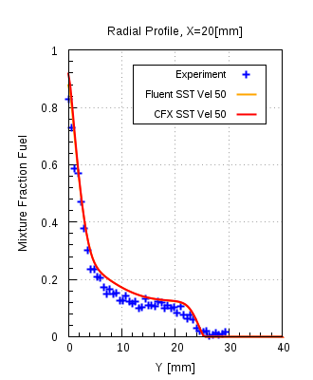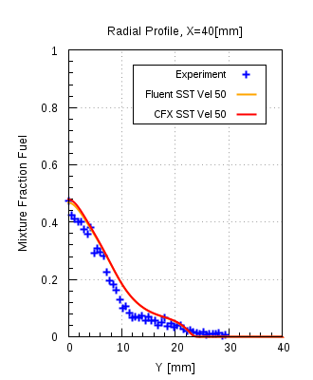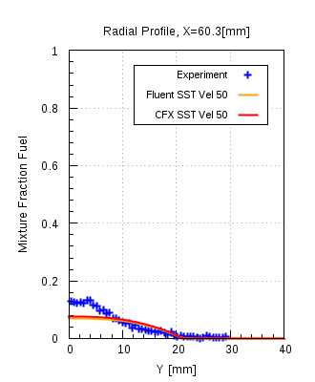

Figure 12.6(d)

UJ  = 85 m/s

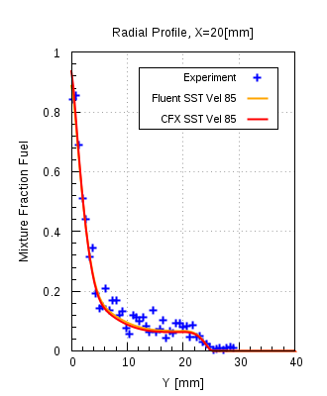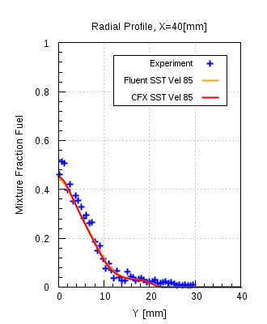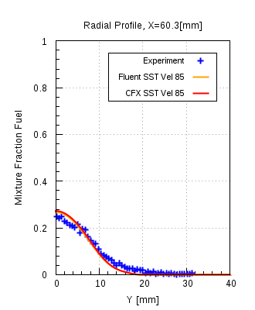

Figure 12.6(e)

UJ  = 143 m/s

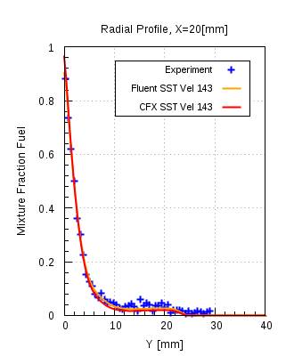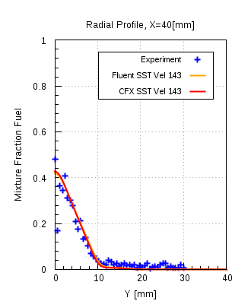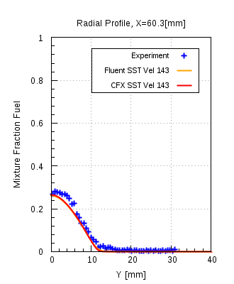

Figure 12.6(f)